TI 23 – 03 Technology Example – Axter Reach Control Line Retrieve tool

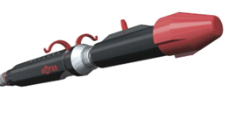

The AxterReach Tool locates and retrieves a line (control line, tube encased cable, wireline cable and similar) from a wellbore. Two gripper arms are rotated circumferentially toward each other to reach a line/microtube and retract it into the tool body for cutting (if required) and/or retrieval.

The AxterReach handles P&A as well as fishing operations. Typical applications may be where a tubing string has parted and the control line needs to be removed to place a plug, or a wireline cable is dropped in a wellbore, and similar.

Mitigates the requirement to pull tubing/control lines/cables for abandonment.

Vendors Web page Link for further information:
AxterReach - Axter

